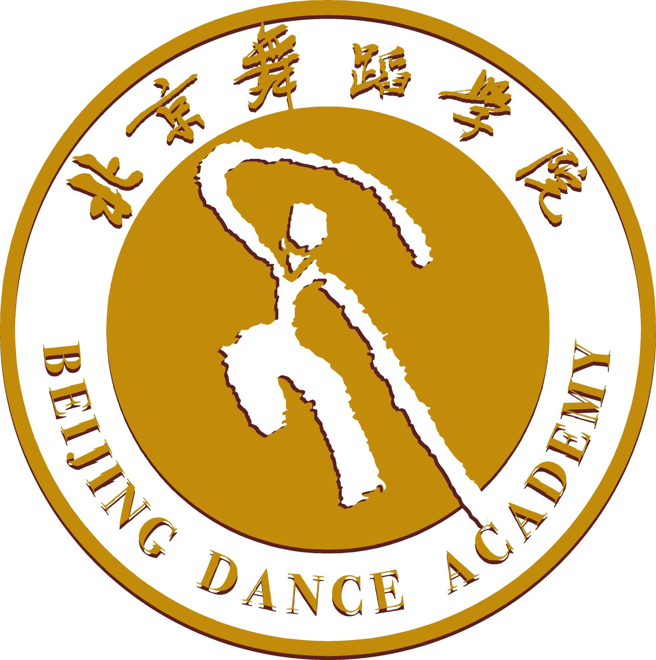
北京舞蹈学院 No.
BEIJING DANCE ACADEMY 收表日期
（to be officially used only）

外 国 学 历 生 入 学 申 请 表（ 大 学 ）
Degree Programs Application Form for International Students

·申请截止日期：2021年3月31日以前提交报名材料
Application Deadlines: before Mar. 31st 2021

·申请项目（请按学院最新招生简章中的有关信息填写）
Application Programs（According to the up-to-date Audition information from BDA）
1) 学生类别 Student Status 本科生 Undergraduate □ 研究生 Graduate £
2) 报考院系及专业/研究方向 Department & Major/ Research Area
3) 申报导师(研究生申请者请填此项) Supervisor（for Graduate Applicants only）
4) 计划在校学习时间 Expected Duration of Study at BDA 年Y 月 —— 年Y 月
5) 学习期间经费来源Source of Funding 奖学金 Scholarship□ 自费 Self-supporting£ 其它 Other□

1．个人信息 Personal Information
护照姓名  Name as in the Passport | 姓Family Name |  |  |  |  |  |  |  | 照 片  Photo
护照姓名  Name as in the Passport | 名Given Name |  |  |  |  |  |  |  | 照 片  Photo
中文姓名 Chinese Name |  |  | 性别Gender |  |  |  | 身高  Height |  | 照 片  Photo
国籍 Nationality |  |  | 宗教 Religion |  |  |  |  |  | 照 片  Photo
出生地点Country and City of Birth |  |  |  |  |  | 出生日期 Date of Birth 年Y 月M 日D
母亲姓名Mother's name |  |  |  |  |  | 母亲国籍Nationality of mother
父亲姓名Father's name |  |  |  |  |  | 父亲国籍Nationality of father
婚姻状况Marital Status |  |  |  | 最后学历Highest Academic Degree Obtained
护照号码 Passport No. 有效期至 Date of expiration 年Y 月M 日D
电话Tel |  | 传真 Fax |  |  |  |  | 电子邮件E-mail
通信地址 Mailing Address
家庭住址和电话 Home Address & Tel
毕业院校 Name of your Graduate School
主修专业 Field of Study
现工作或学习单位 Employer or Institution Affiliated
职业或职务 Occupation / Status
2. 教育背景
Educational background
学校 Institutions | 在校时间Date entered and left | 状态Qualification obtained
特长及爱好/Special skills or interests：

3. 语言能力 Language Proficiency
HSK考试等级 (如果有请填写) / Level of HSK Test (If appropriate )
汉语熟练程度 Chinese Ability 很好Excellent □ 好 Good □ 一般 Fair □ 初学 Beginning □

4．家庭紧急联系人Family Emergency Contacts
关系Relationship | 姓名Name | 联系电话Tel. | 邮件E-mail

5. 推荐人或机构Referee
推荐人姓名/推荐机构名称 Name of Referee
联系电话Tel. | 邮件E-mail
联系地址Address
推荐人签字Signature of Referee |  | 日期Date

6．申请人保证 I hereby affirm that
1) 上述各项中所提供的情况是真实无误的。
All the information in this form is true and correct.
2) 在校学习期间遵守中国政府的法律和学校的规章制度。
I shall abide by the laws of the Chinese Government and the regulations of BDA

申请人签字 日期
Signature of Applicant Date

（申请人保证须申请人本人签字，没有本人签名，视为申请无效。）
（The application is invalid without the applicant’s signature.）
7. 申请清单 Application Checklist
申请人在递送本申请表的同时，请提交以下材料 Please send with the form Below
1）护照首页复印件 Copy of the Information page of your Passport
2）4张2寸照片4 Photos（2inch, 4.8x3.3cm）
3）个人简历（Resume）
4）《外国留学生在华事务担保人保证书》及担保人有效证件的复印件
Guarantor Form and photocopy of guarantor’s credentials (passport or ID.)
5）最高学历证书及成绩单复印件，应届毕业生需提供预期毕业证明原件。
The photocopy of applicant’s highest degree obtained and transcripts.If the applicant is still in the final year, a certificate of expected graduation issued from the school is required.
6) 新版汉语水平考试（HSK）4级或5级证书The band 4 or 5 of new HSK
7) 当年9月1日仍未满18周岁的申请人，须同时提供《监护人保证书》（监护人应为在北京居住，有经济来源的中国人或外国人）和北京公证处出具的公证书（专业考试通过后提供）
For applicants under 18 years old on Sept. 1st, a Guardian's Letter of Guarantee and Notarial Certificate issued issued by a notary office in Beijing shall be submitted together. The guardian of the student has to be living in Beijing at present. Whatever the guardian’s nationality is, he or she must have a source of income.(Submit after passing the audition)
8）对符合教育部教外来（2009）83号文规定，原为中国公民后加入外国国籍者，申请时需提交：①入籍证明；②注销原中国户籍证明；③最近4年的护照出入境签章页复印件；④最近2年的国外学习经历证明。
According to the Document No. 83 from the Ministry of Education of China, applicant who abandoned his/her Chinese Nationality then joined a foreign nationality, should submit the documents as follows: ①Naturalization prove; ②Proof of cancellation of the original residence; ③A photocopy of exit signature pages of the passport in recent four years; ④Study certificate in the abroad in recent two years.
以下材料仅研究生申请者提供 Graduate applicants should also submit below :
1）与专业相关的论文Relevant Thesis
2）两名教授的推荐信Letters of Recommendation from two Professors

无论是否被录取，上述申请材料恕不退还。
Whether the candidate is accepted or not, all the application materials will not be returned.

注意：填写字迹工整、清楚，不得遗漏。请按最新《北京舞蹈学院外国留学生招生指南》要求提供相应证明文件。
Applicants should write neatly and clearly. Please fill in every section of the form and submit this form together with copies of all other documents required in ‘Beijing Dance Academy Guideline for International Students’.

